Kadastrale info

Appartement 2B 0003

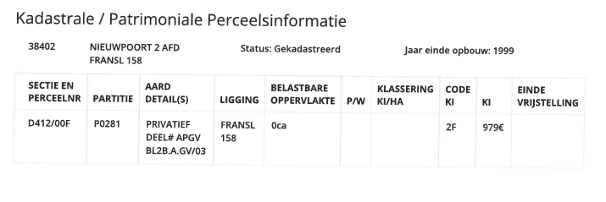
Berging 16
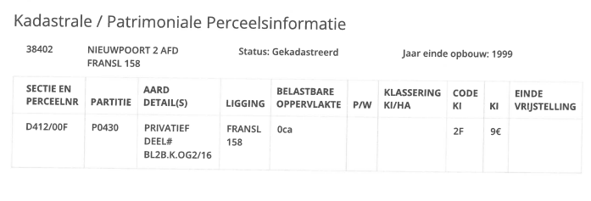
Parking 429
